**Program 4**

**Create maven project and Migrate to gradle**

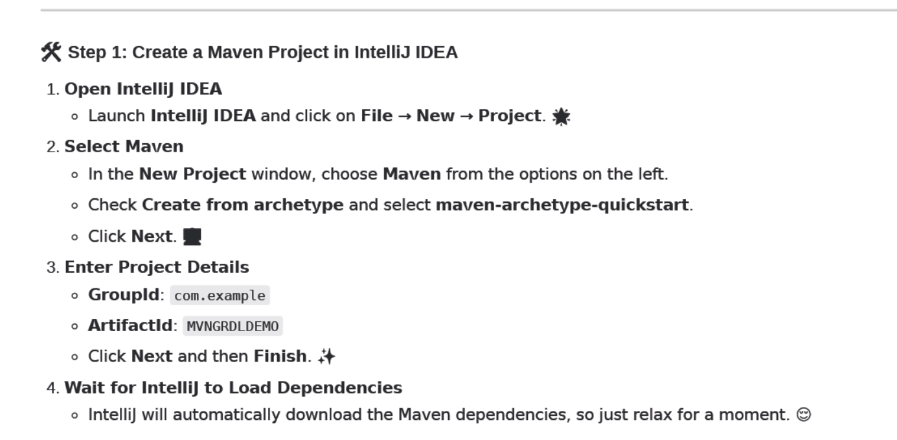

1. **Build Plugin used to create JAR file of MAVEN**

* **Copy Paste the below code in POM after <dependencies> i.e inside the <project>**

**<build>**

**<plugins>**

**<!-- Compiler Plugin -->**

**<plugin>**

**<groupId>org.apache.maven.plugins</groupId>**

**<artifactId>maven-compiler-plugin</artifactId>**

**<version>3.8.1</version>**

**<configuration>**

**<source>1.8</source>**

**<target>1.8</target>**

**</configuration>**

**</plugin>**

**<!-- Jar Plugin -->**

**<plugin>**

**<groupId>org.apache.maven.plugins</groupId>**

**<artifactId>maven-jar-plugin</artifactId>**

**<version>3.2.0</version>**

**<configuration>**

**<archive>**

**<manifest>**

**<mainClass>com.example.App</mainClass>**

**</manifest>**

**</archive>**

**</configuration>**

**</plugin>**

**</plugins>**

**</build>**

* **Then go to Command Prompt and type**

**mvn clean compile**

**mvn package**

* **Jar file will be created in target directory.**
* **In command prompt type: java -jar target/MVN (three letters of your project) and press TAB**

**Main java class (default program in project) gets executed.**

1. **To migrate MAVEN projec t to GRADLE**

**In command Prompt type: gradle init --type pom**

**(above command with migrate the Maven POM to Gradle build.gradle)**

1. **To create JAR file in gradle Copy the below cope in build.gradle**

plugins {

id 'java'

}

group = 'com.example'

version = '1.0-SNAPSHOT'

repositories {

mavenCentral()

}

dependencies {

testImplementation 'junit:junit:4.13.2'

}

jar {

manifest {

attributes(

'Main-Class': 'com.example.App'

)

}

}

* **Then go to Command Prompt and type**

**Gradle clean build**

* **Jar file will be created in build directory 🡪 Libs🡪 jar.**
* **In command prompt type: java -jar build/libs/MVN (three letters of your project) and press TAB**

**Main java class (default program in project) gets executed .**